COVER PAGE

IIE MSA

WEB DEVELOPMENT

WEDE5020

POE – PART 1

STUDENT NUMBER: ST10201572

NAME: DIYA

SURNAME: SEWNARAIN

BUSINESS NAME: COSMETICS CLINIC

BUSINESS LOGO:

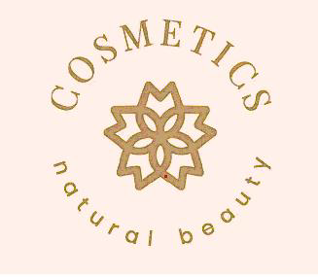

WEBSITE CHOICE 2

WEBSITE ASSESTS: 3

WEBSITE PAGES AND CONTENT 5

REFERENCES: 5

POE – PART 2 5

UPDATED REFERENCES: 5

# WEBSITE CHOICE

Business Name: Cosmetics Clinic

Description of Business: This business offers a wide variety of skincare products to choose from and look at. This is a hypothetical business and does not have any type of social media platform or website. Cosmetics Clinic is a business committed to providing the right skincare products to suit all types of skin.

Reason why I chose this business: The website of this business aims to help users find the ideal products for their skin, providing access to well-known skin care products. We stock a variety of international and local skin care brands that ensure healthy, radiant, glowing skin.

Motivation: A well designed and organized website gives users the confidence to interact with the business as it appears real and professional.

Via search engines, you might reach those who would not otherwise be aware of your existence.

Potential customers get a professional impression of your business when you provide a unified brand identity to them.

Your website may accurately portray your brand identity and work in conjunction with any actual business locations.

At Cosmetics Clinic, we are dedicated to providing you with the finest skincare products that promote healthy and radiant skin. Our carefully curated collection consists of premium skincare solutions designed to nourish, revitalize, and enhance your natural beauty.

We aim to help users find the ideal products for their skin, providing access to well-known skin care products. We stock a variety of international and local skin care brands that ensure healthy, radiant, glowing skin

# WEBSITE ASSESTS:

Different types of images – The images/photos used on the website are all different types of product images. We make sure all the images are of a high quality as well as visually appealing.

Using Adobe Photoshop which allows us to optimize the images and reduce the file size without compromising image quality.

The different skincare products we sell belong to different companies and have given us the permission and consent to sell their products.

Cleansers and Toners: Start your skincare routine right with our gentle and effective cleansers and toners. They remove impurities, balance your skin's pH, and prep it for further treatment.

Moisturizers and Serums: Nourish and hydrate your skin with our range of moisturizers and serums. Packed with potent ingredients, they target specific concerns such as hydration, anti-aging, brightening, and more.

Masks and Treatments: Pamper your skin with our rejuvenating masks and targeted treatments. From sheet masks to clay masks, we have a variety of options to give your skin that extra boost.

Sun Protection: Shield your skin from harmful UV rays with our broad-spectrum sunscreens. Our lightweight and non-greasy formulations protect your skin while keeping it healthy and radiant.

Specialized Products: We offer a range of specialized products such as eye creams, lip balms, and spot treatments to address specific skincare needs and concerns.

Company Logo -



Product photos – All products come with a description which highlights the features and provides relevant information on each product.

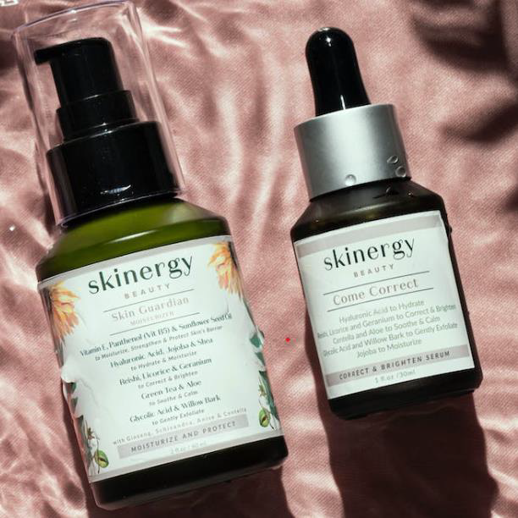  
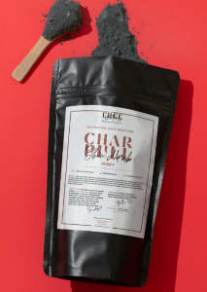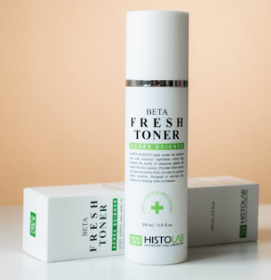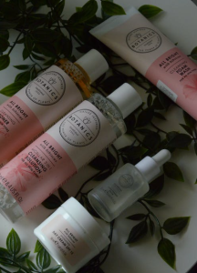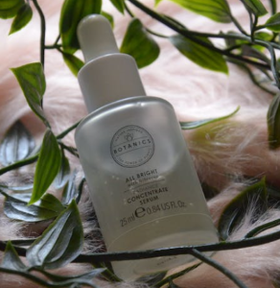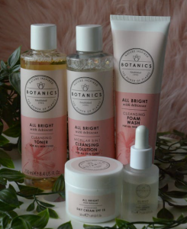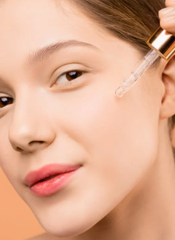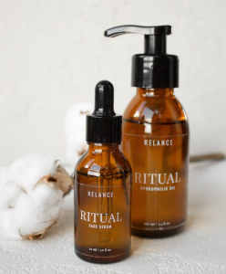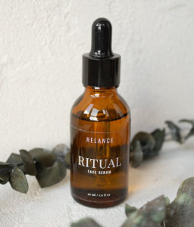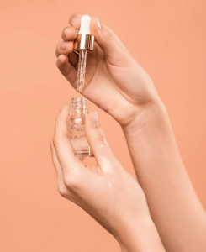

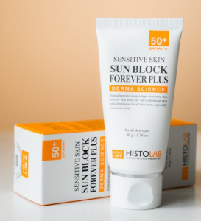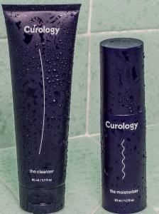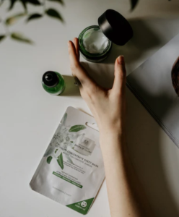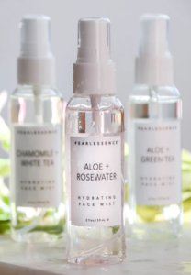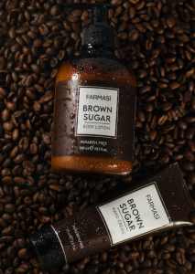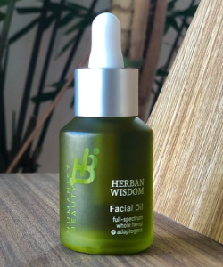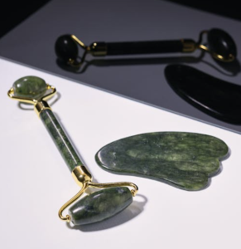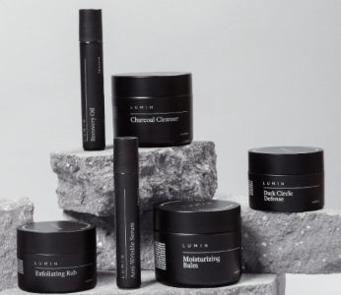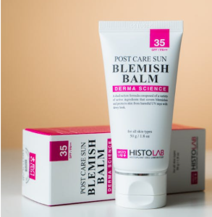

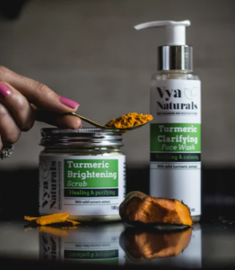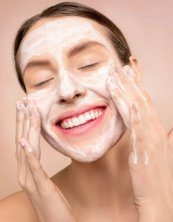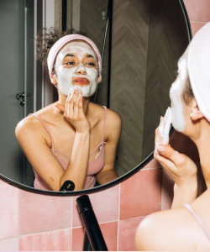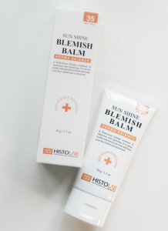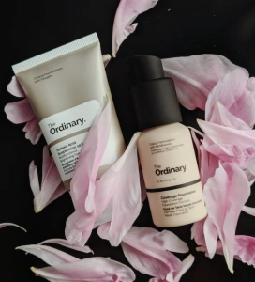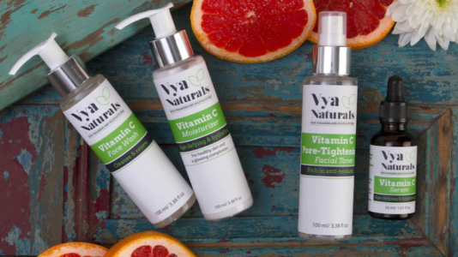

WEBSITE PAGES AND CONTENT:

1) Homepage

− Logo of business

− Slogan

− Navigation Menu

− Full – width photo

− Summary of main activities

− Basic contact information

− Copywrite/ Year

2) About Us Page

− Mission Statement

− Description of Business

− Brief History of business

− Business values

− Some contact information

− Copywrite/ Year

3) Products

− Header Image

− Navigation Link to Products and Product Brands

− All different types of skincare products sold and description

− Copywrite/ Year

4) Articles

− Explanation of all different types of products sold

− How effective they are and what they do to your skin

− Frequently asked questions

− Copywrite/ Year

5) Contact Us

− Business Logo

− Business Overview

− Contact information and details

− Map/directions to physical store

− Copywrite/year

# REFERENCES:

Images and Photos -

Pexels (no date). Available at: https://www.pexels.com/ (Accessed: April 3, 2023).

Unsplash (no date) Beautiful free images & pictures, Unsplash. Available at: https://unsplash.com/ (Accessed: April 3, 2023).

# POE – PART 2

IMPROVEMENTS TO PART 1

I noticed that on the POE Part 1 that I did, the navigation menu was not linking to the correct web pages and the webpages were not all linked together. The navigation menu had to be fixed across all pages. I created navigation to the index.html and articles.html but did not create their files.

I did not have a root folder labelled with the name of the business and I did not have sub folders containing my _images and _private. I did not include the _images and _private subfolders in your root folder, where all image assets are stored in the _images folder, while copies (text info of the business) are stored in the _private folder.

I did not have a detailed list of resources for the creation of my website. I only focused on my images and not on information about the company, mission statement, history of the business, and a description of my product and services.

I did not add enough content to all my web pages as well as images. I left out content on all my products as well as descriptions and what the company is about. I did not have any images in my POE Part 1.

IMPROVEMENTS AND CORRECTIONS

Firstly, I fixed my navigation menu across all the web pages, making sure they all link to one another and the current page I’m on does not have a link.

I added the company’s logo to all the web pages.

This was done from line 13 to line 22

I included the navigation menu in the footer of the web pages as well to make it easier for users to navigate through the website.

Home Page – I noticed that my home page was not named as index.html, I fixed this error.

In the main tag of the home page, I added much more content about what Cosmetics Clinic does from line 29 to 31 as well as visually appealing images on line 27.

I also included some of our Featured Brands from line 33 to 49.

About Page – I added content in this page about the company. A brief summary of the business in line 30. I also added the mission statement of the business in lines 37 and 38. I included a vision of the business and what the future plans of the business are in lines 41 and 42.

I also added the names of the most important people who help run the company in lines 46 to 52.

Products and Services Page – I included the range of different products that we sell and why it is important.

I added images and descriptions of each product that Cosmetics Clinic sells and the prices of each product from our bestsellers to all our different brands.

Articles Page – This page includes the latest and most popular articles about skincare. Therefore, I did some research about the trendiest articles and included these articles as well as some pictures. I also added some advice from experts on how to get rid of acne (Line 40) as well as an effective morning and evening skincare routine to help users choose the right products in their routine.

Contact Us Page – I did not change much on this page other than some extra contact information in line 33.

I also imbedded a google maps to help users get directions directly to the Cosmetics Clinic Store. (Line 39 to 44)

Additional Information Added

Products Information -

Skinergy beauty – moisturizer

Skinergy beauty – brightening serum

Botanics – All Bright – Foam Wash

Botanics – All Bright – Cleansing Solution

Botanics – All Bright – Toner

Botanics – All Bright – Day Cream SPF 18

Botanics – All Bright – Concentrate Serum

Farmasi – Brown Sugar – Body Lotion

Farmasi – Brown Sugar – Hand Cream

Relance – Ritual – Face Serum

Relance – Ritual – Sydrophilic oil

Vya Naturals – Turmeric Clarifying Face Wash

Vya Naturals – Turmeric Brightening Scrub

Herban Wisdom – Facial oil

Curology – The Cleanser

Curology – The Moisturizer

Face Mist – Aloe and Rosewater

Face Mist – Chamomile and White Tea

Face Mist – Aloe and Green Tea

Lumin – Charcoal Cleanser

Lumin –Exfoliating Scrub

Lumin – Recovery Oil

Lumin – Anti – Wrinkle Serum

Lumin – Moisturizing Balm

Lumin – Dark Circle Defense

About us Page -

Our Mission

At Cosmetics Clinic, our mission is to empower individuals to embrace their natural beauty and achieve their skincare goals through advanced and personalized skincare solutions. We are dedicated to providing exceptional products, professional expertise, and a nurturing environment that fosters self-confidence, wellness, and lasting results.

Driven by the desire to make a positive impact in the lives of our clients, we embarked on a journey to curate a range of skincare products that combine cutting-edge science with nature's finest ingredients. Our team of experienced dermatologists, aestheticians, and skincare professionals meticulously researched and tested each product to ensure optimal results and safety.

Our Vision

Looking ahead, we are committed to pushing the boundaries of skincare innovation, introducing new products, and expanding our services to meet the evolving needs of our clients.

As a company, we believe in the power of education and empowerment. We strive to not only provide exceptional skincare products but also educate our clients on the importance of a comprehensive skincare routine and self-care practices. Through our informative resources, personalized consultations, and expert advice, we empower individuals to take control of their skin health and embrace their natural beauty.

Our Team

Our team consists of skincare experts who are passionate about helping our customers achieve their best skin. From our customer service representatives to our product specialists, everyone at Cosmetics Clinic is dedicated to providing you with the best possible shopping experience.

Diya Sewnarain - Founder and CEO

Jane Smith - Product Specialist

Mark Johnson - Marketing Manager

Lisa Kim - Customer Service Representative

Articles Page -

On this page, I added all the articles.

How to Get Rid of Acne: Tips and Tricks

Acne is a common skin concern that affects people of all ages. Dealing with acne can be frustrating and may affect one's self-confidence. However, with the right knowledge and skincare routine, you can effectively manage and minimize acne breakouts. In this article, we will explore valuable tips and tricks to help you get rid of acne and achieve clearer, healthier skin.

Cleanse your skin effectively:

Start your acne-fighting routine with a gentle cleanser that is suitable for your skin type. Look for products that contain salicylic acid or benzoyl peroxide, as they help to unclog pores and reduce acne-causing bacteria. Cleanse your face twice daily to remove dirt, excess oil, and impurities.

Moisturize with care:

Contrary to popular belief, moisturizing is essential for acne-prone skin. Opt for oil-free and non-comedogenic moisturizers to avoid clogging your pores. Look for ingredients like hyaluronic acid or niacinamide, which provide hydration without causing breakouts. Proper hydration helps maintain a balanced and healthy skin barrier.

Exfoliate regularly:

Exfoliation is key to removing dead skin cells that can clog pores and contribute to acne formation. However, be gentle when exfoliating to avoid irritating your skin. Use chemical exfoliants containing alpha-hydroxy acids (AHAs) or beta-hydroxy acids (BHAs) to unclog pores and promote cell turnover. Start with once or twice a week and gradually increase frequency if your skin tolerates it.

Spot treatment for targeted care:

When dealing with active breakouts, spot treatments can be highly effective. Look for products containing ingredients like tea tree oil, benzoyl peroxide, or sulfur, which help to reduce inflammation and kill acne-causing bacteria. Apply a small amount directly to the affected area before bed and allow it to work overnight.

Maintain a healthy lifestyle:

While skincare plays a crucial role in managing acne, lifestyle factors also contribute to overall skin health. Ensure you are getting enough sleep, managing stress levels, and maintaining a balanced diet. Incorporate foods rich in antioxidants and avoid excessive consumption of processed and sugary foods that can trigger breakouts.

Selecting the Right Serum in Your Skincare Routine:

Serums can be a game-changer in your skincare routine, providing concentrated active ingredients to target specific concerns. When it comes to selecting the right serum for acne-prone skin, consider the following factors

Ingredients: Look for serums with acne-fighting ingredients like salicylic acid, niacinamide, or retinol. Salicylic acid helps to unclog pores, niacinamide soothes inflammation, and retinol promotes cell turnover and reduces acne scars.

Skin type compatibility: Consider your skin type when choosing a serum. If you have oily or combination skin, opt for lightweight, oil-free serums that won't contribute to excess oiliness. Dry or sensitive skin types may benefit from hydrating and soothing serums.

Avoid potential irritants: Some serums contain fragrances, alcohol, or other potential irritants that can worsen acne-prone skin. Opt for fragrance-free and non-irritating formulas to minimize the risk of skin irritation and breakouts.

Creating an Effective Morning And Evening Skincare Routine

Taking care of your skin is essential for maintaining its health, radiance, and youthful appearance. Establishing a consistent morning and evening skincare routine can greatly contribute to achieving these goals. In this article, we will guide you through the key steps for an effective morning and evening skincare routine.

Morning Skincare Routine:

Cleansing: Start your day by cleansing your face to remove any dirt, oil, and impurities that have accumulated overnight. Use a gentle cleanser suitable for your skin type, and massage it into your skin in circular motions. Rinse thoroughly with lukewarm water and pat dry.

Toning: Follow cleansing with a toner to balance your skin's pH levels and prepare it for further products. Choose a toner that suits your skin type, whether it's hydrating, clarifying, or soothing. Apply the toner using a cotton pad or gently pat it into your skin with clean hands.

Antioxidant Serum: Next, apply an antioxidant serum enriched with ingredients like vitamin C or green tea extract. Antioxidants help protect your skin against free radicals and environmental stressors, while also brightening and improving skin tone. Gently massage the serum onto your face and neck.

Eye Cream: Treat the delicate skin around your eyes with an eye cream. Look for a formula that addresses your specific concerns, such as dark circles, puffiness, or fine lines. Apply a small amount using your ring finger and gently tap it around the eye area.

Moisturizer: Hydrate and nourish your skin with a moisturizer suited to your skin type. Choose a lightweight, non-comedogenic formula for oily or combination skin, and a richer texture for dry skin. Massage the moisturizer in upward motions until fully absorbed.

Sunscreen: Protect your skin from harmful UV rays by applying a broad-spectrum sunscreen with at least SPF 30. Apply it generously to your face, neck, and any exposed skin. Reapply every two hours, especially if you spend prolonged periods outdoors.

Evening Skincare Routine:

Makeup Removal: Begin your evening routine by thoroughly removing any makeup with a gentle makeup remover or cleansing balm. Ensure that all traces of makeup are eliminated to allow your skin to breathe and regenerate overnight.

Double Cleansing: Follow makeup removal with a double cleansing method. Start with an oil-based cleanser to dissolve any remaining makeup, sunscreen, and excess oil. Then, use a water-based cleanser to deeply cleanse your skin and remove impurities. Rinse with lukewarm water and pat dry.

Exfoliation (2-3 times a week): Exfoliate your skin to remove dead skin cells and promote a smoother, more radiant complexion. Choose a chemical exfoliant with AHAs or BHAs rather than physical scrubs, as they are generally gentler. Massage the exfoliant onto your damp face and rinse thoroughly.

Treatment Products: Apply any targeted treatment products, such as acne treatments, retinol, or serums, as recommended by your skincare professional. These products can address specific concerns and promote skin renewal. Follow the instructions provided and allow sufficient time for the products to penetrate your skin.

Eye Cream: Apply your chosen eye cream or gel in the same manner as in your morning routine. Gently tap it around the eye area using your ring finger, as this finger applies the least pressure.

Moisturizer or Night Cream: Replenish your skin's moisture with a nourishing moisturizer or night cream. Look for ingredients like hyaluronic acid, peptides, or ceramides to hydrate and repair your skin while you sleep. Massage the product onto your face and neck using upward motions.

Lip Care: Don't forget to pamper your lips with a hydrating lip balm or treatment before bed. Apply a thin layer to keep your lips moisturized and prevent dryness.

# UPDATED REFERENCES:

(26 May 2023) *What is serum: How to choose the best serum for your skin - the ...* Available at: <https://theskincareedit.com/what-is-serum> (Accessed: 26 May 2023).

*5 tips for healthy, glowing skin* (2022) *Mayo Clinic*. Available at: <https://www.mayoclinic.org/healthy-lifestyle/adult-health/in-depth/skin-care/art-20048237> (Accessed: 27 May 2023).

*Acne* (2022) *Mayo Clinic*. Available at: <https://www.mayoclinic.org/diseases-conditions/acne/diagnosis-treatment/drc-20368048> (Accessed: 27 May 2023).

Cox, L.K. (2023) *27 best about Us and about me page examples [+templates]*, *HubSpot Blog*. Available at: <https://blog.hubspot.com/marketing/remarkable-about-us-page-examples> (Accessed: 26 May 2023).

Team, T.H.E. (2018) *Healthy Beauty and skin care*, *Healthline*. Available at: <https://www.healthline.com/health/beauty-skin-care> (Accessed: 28 May 2023).